[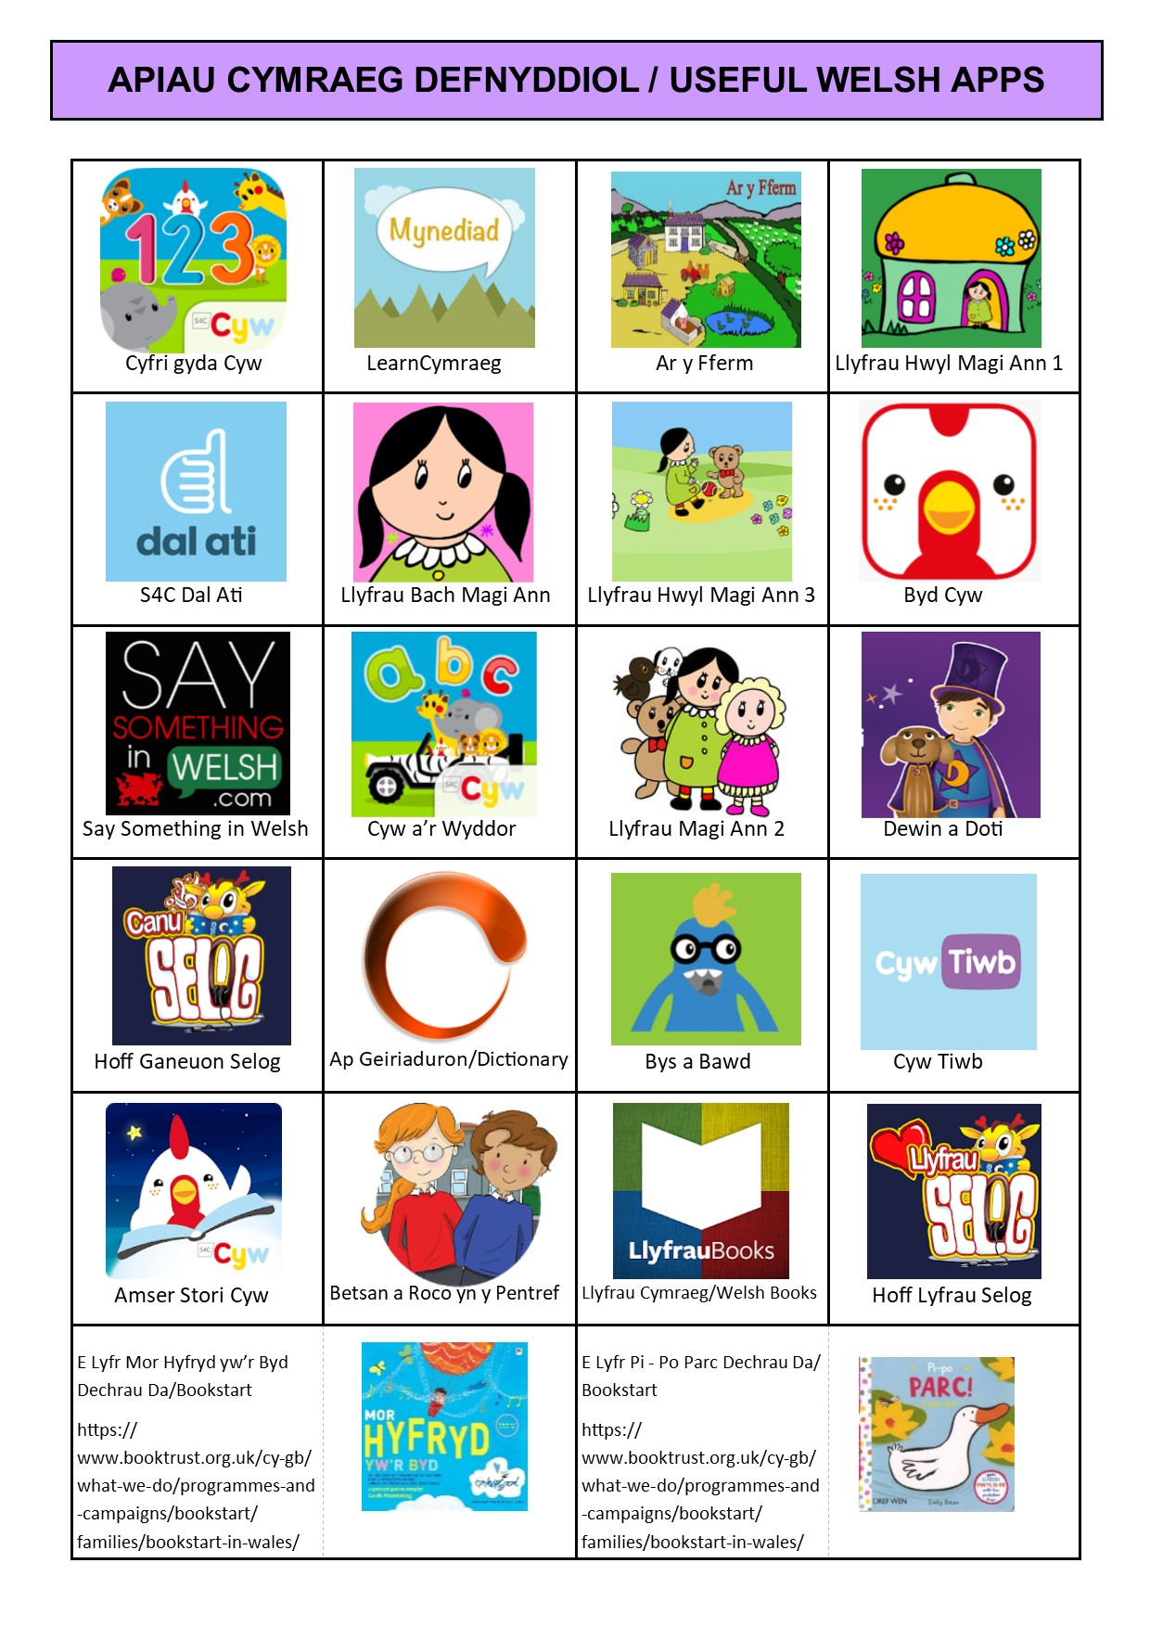](https://www.google.com/url?sa=i&url=https%3A%2F%2Ffis.carmarthenshire.gov.wales%2Fparenting%2Fwelsh-language%2F&psig=AOvVaw35qfVu10xl42Cp7eBlAyaC&ust=1584552189652000&source=images&cd=vfe&ved=0CAIQjRxqFwoTCLjB8YaDougCFQAAAAAdAAAAABAX)[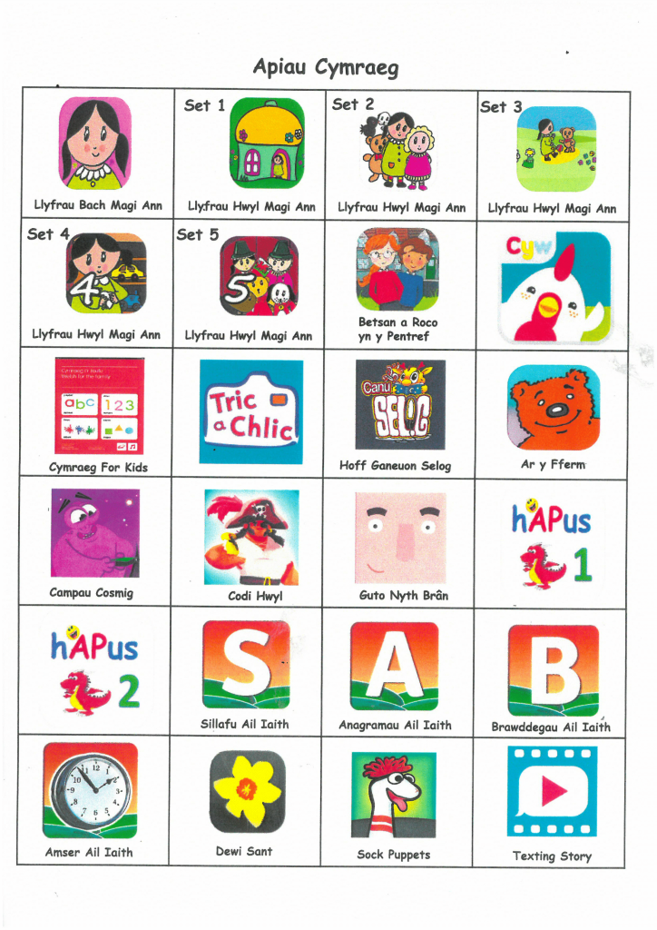](https://builth-wells-cp-school.j2bloggy.com/2018/05/cymraeg-campus/cymraeg-campus-3/)